**Neural Networks**

**Course 2:**

**Hyper Parameters Tuning**

**Week 2-3**

**Submitted to Dr. Omar Nasr**

**Prepared by: Mona Mamdouh**

# **Mini-Batch gradient decent**

The data is divided into mini-batches as follows

Batch#3

Batch#m

Batch#2

Batch#1

…………………..

The network is trained by each batch and take one gradient step, the cost function in mini batch is noisy as the cost is measured on a mini batch.

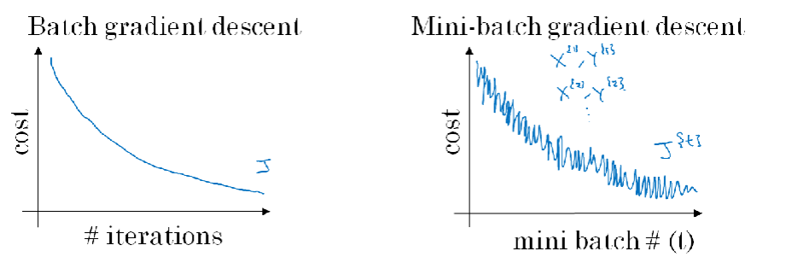

* Choose the mini batch size is according to :
  + Mini-batch size = m (returns to batch gradient decent)
  + Mini-batch size = 1 (stochastic gradient decent 'very noisy')
  + Practically the used number is in between to make progress without waiting all the data to be processed.
* To remove the noise in the cost function in case of mini batch we use the momentum average technique.

# **The momentum gradient decent**

* In iteration t we compute dw, wb, on the current mini-batch
* Then we compute

$$V_{dw}=βV_{dw}+\left(1-β\right) dw$$

$$V_{db}=βV_{db}+\left(1-β\right) db$$

Where $β$ a new hyper parameter is usually set to 0.9,

And $V_{dw}, V_{dw}$ is initialized to zero

$$W=W-∝ V_{dw}$$

$$b=b-∝ V_{db}$$

# **RMS prop**

* In iteration t we compute dw, wb, on the current mini-batch
* Then we compute

$$S_{dw}=B_{2}S_{dw}+\left(1-B_{2}\right) dw^{2}$$

$$S_{db}=B_{2}S_{db}+\left(1-B_{2}\right) db^{2}$$

Where $B_{2}$ a new hyper parameter,

$$W=W-∝\frac{dW}{\sqrt{s_{dw}}}$$

$$b=b-∝ \frac{dW}{\sqrt{s_{db}}}$$

# **Adam optimization algorithm**

* In iteration t we compute dw, wb, on the current mini-batch
* Then we initialize $S_{dw}=S_{db}=V_{dw}=V_{db}=0$

$$S_{dw}=B_{2}S_{dw}+\left(1-B_{2}\right) dw^{2}$$

$$S_{db}=B_{2}S_{db}+\left(1-B_{2}\right) db^{2}$$

Where $B_{2}$ a new hyper parameter,

$$W=W-∝\frac{dW}{\sqrt{s_{dw}}}$$

$$b=b-∝ \frac{dW}{\sqrt{s_{db}}}$$